1. Install Docker
yum remove -y docker \
docker-client \
docker-client-latest \
docker-common \
docker-latest \
docker-latest-logrotate \
docker-logrotate \
docker-selinux \
docker-engine-selinux \
docker-engine
yum install -y yum-utils device-mapper-persistent-data lvm2
yum-config-manager --add-repo https://download.docker.com/linux/centos/docker-ce.repo
yum install -y docker-ce
systemctl enable docker
usermod -aG docker root
systemctl start docker

2. Pull the image
sudo docker pull qiyeim/rtcserver:latest

3. Operation
sudo docker run -itd --restart=always -e "ACCEPT_EULA=Y" -e "SA_PASSWORD=Qiyeim.com" \
-p 1433:1433 -p 97:97 -p 98:98 -p 99:99 -p 5994:5994 -p 5995:5995 -p 5996:5996 -p 5997:5997 -p 5998:5998 \
-p 6001:6001 -p 6002:6002 -p 6003:6003 -p 6004:6004 -p 6005:6005 -p 6006:6006 -p 6007:6007 -p 6008:6008 --name rtcserver \
-d qiyeim/rtcserver:latest
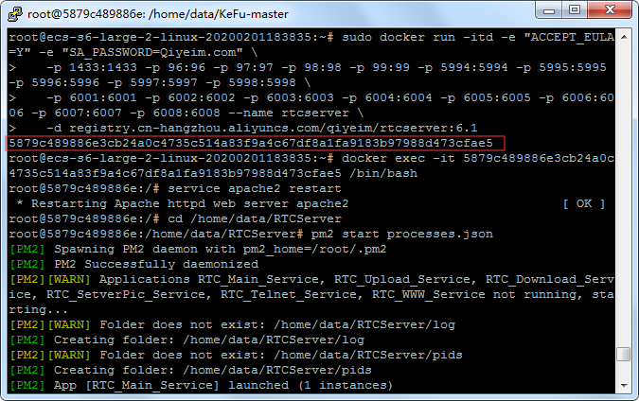
Returns the container ID and opens Docker
sudo docker exec-u 0-it containerID /bin/bash
Enter in the Docker terminal
sudo service apache2 restart
Open http://server IP:98 and configure the database (click Next directly without changing the database name or password).
cd /home/ubuntu/RTCServer
sudo pm2 start processes.json
/etc/init.d/redis-server start
cd /home/ubuntu/KeFu-master
sudo pm2 start bin/www --name kefu
4. Set up the server
4.1 Automatically run the Docker script upon startup
chmod +x /etc/rc.d/rc.local
vi /etc/rc.d/rc.local
Add the following script at the end
sudo sleep 20
sudo docker start container ID
sudo sleep 20
sudo docker exec container ID /bin/sh /ubuntu/data/run.sh
If the above steps don't work, save the script as autostart.sh and refer to Method 2 at https://www.cnblogs.com/longchengruoxi/p/11451062.html
4.2 Set the server to restart automatically every day
sudo su
vi /etc/crontab
add
00 02 * * * root reboot
After saving, execute the following
systemctl restart crond.service

